6A – Driving – Lesson 04
Cost & Purchase of Insurance – Accident and Insurance.

Name: _________________

- Use the graph below to answer the following questions.
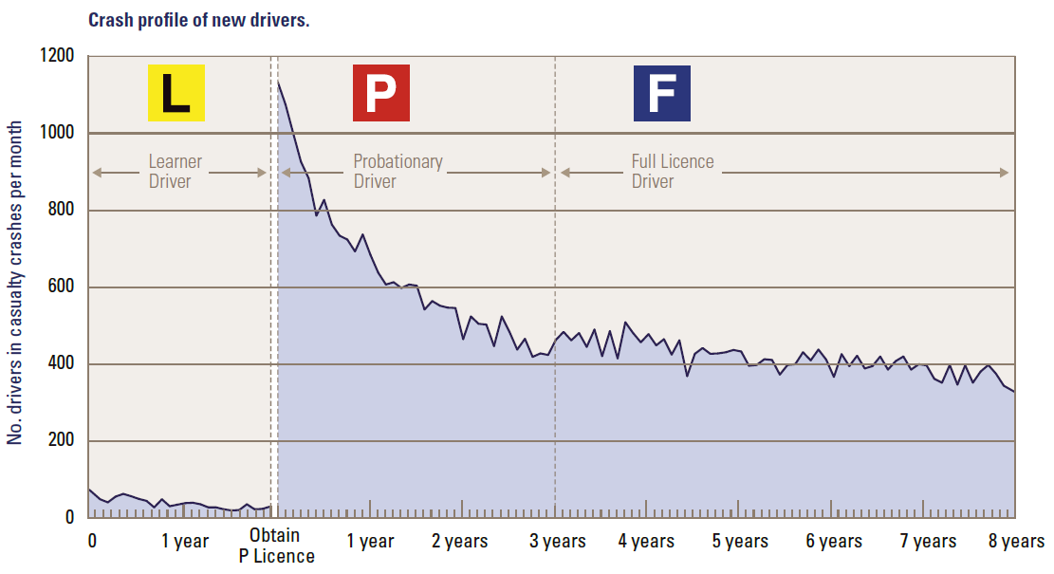

  - Why do people who have little driving experience have to pay higher premiums?

  - Why do learners have so few accidents?

  - How many P-plate drivers with 12 months experience were involved in casualty crashes per month? _______

  - How many Full license drivers with 8 years experience were involved in casualty crashes per month? _______

- Search the internet (or otherwise) to find what is meant by basic excess and an age excess in insurance.
- Use the graph below to answer the following questions.

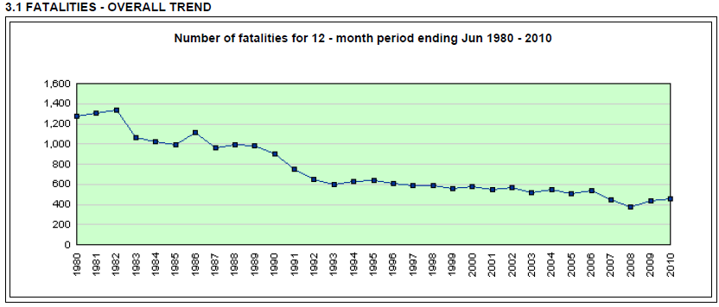
Source: NSW RTA Preliminary Traffic Crash Data Bulletin – June 2010

  - How many people died in 1980? ________

  - How many people died in 2008? ________

  - What trend can be seen in the above graph of car accident fatalities?

  - What affect should the trend shown above have on the real value of car insurance premiums?

- Use the graph below to answer the following questions.

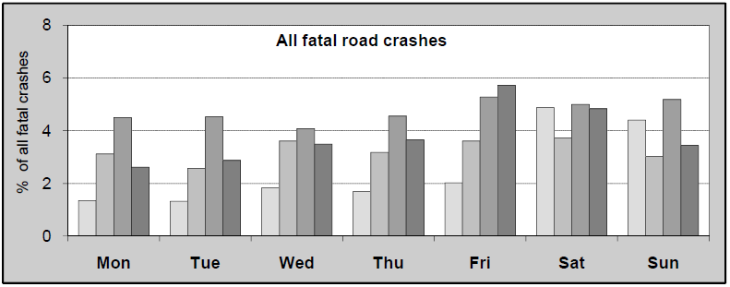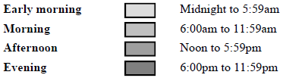
Source: http://www.infrastructure.gov.au/roads/safety/publications/2009/pdf/rsr_04.pdf

  - Which days of the week are worst for fatal crashes? ___________________

  - What time of day is worst for fatal crashes? _____________

  - On a weekday, what time of day has the least accidents? Why is this not true for Saturday and Sunday?

